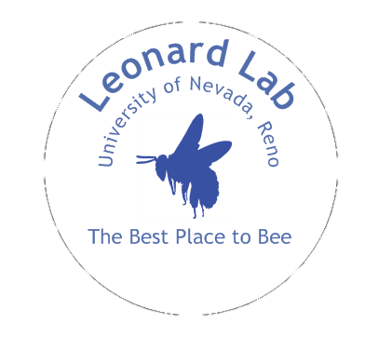
We often have opportunities to involve undergraduates in research. Some students have stayed in the lab for several years, and conducted research for an Honors thesis or equivalent independent project. Although students usually begin by shadowing someone else on a project, we encourage those who are interested in eventually completing independent research to enroll for credit and attend weekly lab meetings. After beginning their own project or helping with a component of a larger experiment, students are encouraged to present their findings (COS or UNR Undergraduate poster session) and to prepare small grant proposals to fund their work (e.g. NVURA, Sigma Xi). We’ve even had students successfully apply for summer research fellowships (e.g. Nevada INBRE) and win national awards for their presentations (Sigma Xi Undergraduate Research Symposium).

A common progression is: volunteering receiving research credit (when possible) being supported by a fellowship or work study. Undergraduates are encouraged to attend weekly lab meetings, where we discuss journal articles, give informal presentations (e.g. practice for an upcoming poster session), and troubleshoot experiments.

More information about current personnel and projects, in addition to downloadable copies of our publications (many of which students have co-authored), can be found at our lab website, www.anneleonard.com

FAQ
1. What time of year do you do your research? We conduct research year round, so often volunteering begins mid-semester or even during a break.

2. Will I get stung? We get perhaps one sting/semester. It could be you! But it is very unlikely you will have an allergic reaction; if so, we have a safety protocol in place.

3. What kinds of things would I be doing? This depends on the particular mentor (grad student, postdoc, or professor) that you are paired with. We usually have some folks who are doing a mix of greenhouse/field/lab work, and others that focus more on behavioral experiments (in lab and field). The time of year and researcher/student interest determines the amount of fieldwork.

4. How many hours per week do you require? We recommend at least 6 hrs/week to get full benefit of spending time in a research lab.

We strongly suggest you spend some time on our lab website http://www.anneleonard.com, reading about projects and skimming over some of our recent publications (all are available to download).
- Name, major and expected graduation date:

- Relevant coursework and grade/s:

- Have you spent time in any other research labs?

- Why are you interested in joining our lab? Are there any projects or topics that you are particularly interested in?

- How many hours/week would you be available (during normal work hours)? (chunks of time at least 2 hrs long work best)

- Which of the following are possibilities for you? (put an “X”)
Volunteer | Federal work study* | BIOL 298° | BIO 491/2°
UNR Honors thesis |  | Other: | “Biology with Distinction” thesis
°More information on BIOL credit can be found on the Departmental Website.
*Federal work study funds are usually a part of a financial aid package.

FINAL STEP: Email this as an attachment to anneleonard@unr.edu

